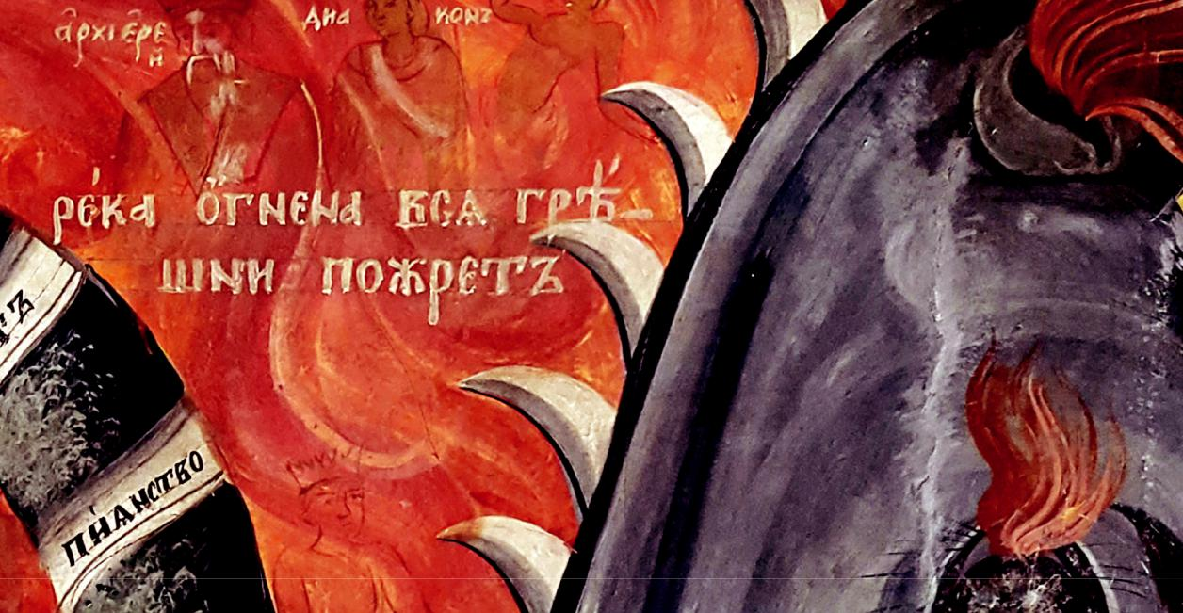

МАРГИНАЛИЯ

съставители Иванка Гергова и
Елисавета Мусакова

Еdited by
Ivanka Gergova and Elissaveta Moussakova

MARGINALIA

Изкуствоlgaедски четения 2018

МАРГИНАЛИЯ

Изкуствоведски четения 2018
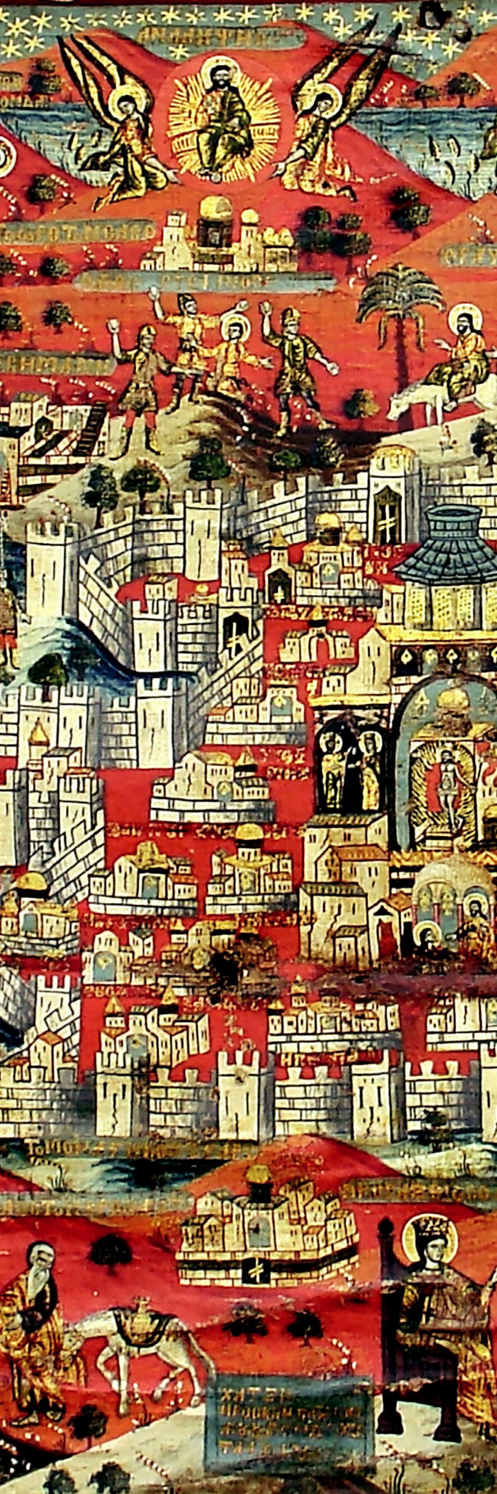

MARGINALIA

Art Readings 2018

Jerusalimia (detail), 1786, Church of St Prophet Elias, Busovača (Bosnia and Herzegovina) (photo: Mаrko Katić)
Ерусалимия (детайл), 1786 г., църква „Св. пророк Илия“, Бусовача (Босна и Херцеговина) (фотография: Марко Катич)

ИЗКУСТВОВЕДСКИ ЧЕТЕНИЯ
Тематичен рецензиран годишник за изкуствознание в два тома

ART READINGS
Thematic Peer-reviewed Annual in Art Studies, Volumes I–II

Международна редакционна колегия International Advisory Board

Andrea Babuin (Italy)
Konstantinos Giakoumis (Albania)
Nenad Makulijević (Serbia)
Vincent Debiais (France)

Редактори от ИИИзк
In-house Editorial Board
Ivanka Gergova
Emmanuel Moutafov

Съставители
Edited by
Ivanka Gergova
Elissaveta Moussakova

Publisher
Institute of Art Studies
21 Krakra Str.
1504 Sofia
Bulgaria

www.artstudies.bg

- Институт за изследване на изкуствата, БАН, 2019
- Institute of Art Studies, BAS, 2019

ИЗКУСТВОВЕДСКИ ЧЕТЕНИЯ
Тематичен рецензиран годишник за изкуствознание в два тома 2018.I. - Старо изкуство

МАРГИНАЛИЯ
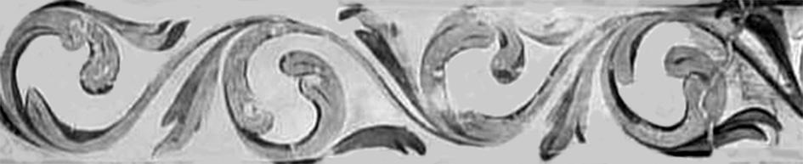

MARGINALIA

ART READINGS
Thematic Peer-reviewed Annual in Art Studies, Volumes I–II
2018.I. Old Art

съставители
Иванка Гергова
Елисавета Мусакова

edited by
Ivanka Gergova
Elissavetа Moussakova

София 2019

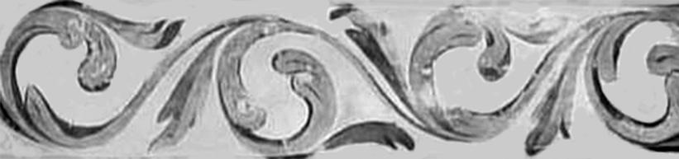

The Three-headed Holy Trinity Icons from Croatia – on the Margins of Post-Byzantine Popular Piety

Aleksandra Kučeković1

Abstract. At the very beginning of the 18th century painter Kozma Damjanović painted three unusual icons of the Holy Trinity and donated them to Orthodox churches in three villages in northern Croatia. They feature a non-canonical image of the Holy Trinity – the figure seated on the throne and with three identical heads on three necks, under one triple crown. The aim of this paper is to shed some fresh light on the unique occurrence of these icons in the specific geographical and historical context, whereby the latter is marked by jurisdictional disputes between Orthodox and Catholic Churches in northern Croatia.

Key words: Christian images, non-canonical, Serbian icon painting, 18th century

All the three icons are of the other type, the one I have never seen anywhere else in our Orthodox iconography or in the West. Ac-cording to the present-day knowledge of our iconography, these three icons of the beardless deity would represent the most re-cent examples of the ‘angelic’ type in Serbian fine arts.

This citation is taken from Radoslav Grujić, a renowned Serbian the-ologian and historian who, in 1955, wrote the first comprehensive study about three-headed representation of the Holy Trinity in Ser-

1 Aleksandra Kučeković is an Associate Professor at the Faculty of Fine Arts, University of Arts, and a lecturer at the Academy of Serbian Orthodox Church for Arts and Conservation in Belgrade; a member of the Board of the Department of Fine Arts of Matica srpska in Novi Sad; a scholar of Serbian early modern and modern religious painting, with a special focus on the art of Slavonia and Northern Croatia.
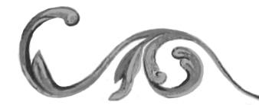

Marginalia

237

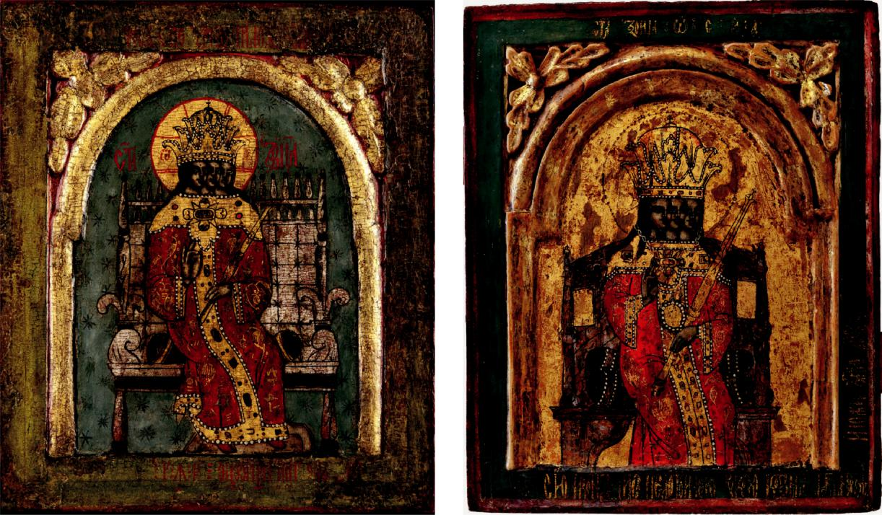

Fig. 1. Holy Trinity, icon, 37 x 31.5 cm, Kozma Damjanović, 1704 (photo: courtesy of Museum of Serbian Orthodox Church, Belgrade)
Фиг. 1. Света Троица, икона, 37 x 31,5 см, Козма Дамянович, 1704 г. (фотография: с любезното разрешение на Музея на Сръбската православна църква, Белград)

Fig. 2. Holy Trinity, icon, 32 x 26 cm, Kozma Damjanović, 1705 (photo: courtesy of Museum of Serbian Orthodox Church, Belgrade)
Фиг. 2. Света Троица, икона, 32 x 26 см, Козма Дамянович, 1705 г. (фотография: с любезното разрешение на Музея на Сръбската православна църква, Белград)

bian medieval and early modern art2. He had discovered three pecu-liar Holy Trinity icons decades earlier when he officiated in Bjelovar in Northern Croatia. In the decade before the First World War, he em-barked on ambitious research of Orthodox churches in the villages sur-rounding the towns of Bjelovar, Križevci and Koprivnica, listing and describing their artifacts, manuscripts and old printed books, icons and iconostases3. The three icons in case are now housed in the Museum of Serbian Orthodox Church in Belgrade (Fig. 1–3). They were painted in 1704 and 1705 by Kozma Damjanović and donated to the churches in three neighboring north Croatian villages – Povelič, Gornje Sredice and Široko Selo. All three icons feature a specific non-canonical image of the Holy Trinity – a single figure seated on the throne, with three identical heads on three separate necks, under a triple crown and en-compassed by a round halo. Although the Orthodox visual tradition

2 Grujić 1955: 99–109.

3 Marković 2014: 163–164; Grujić 2016: 5–22.
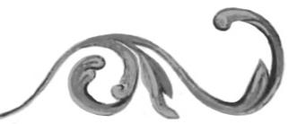

238

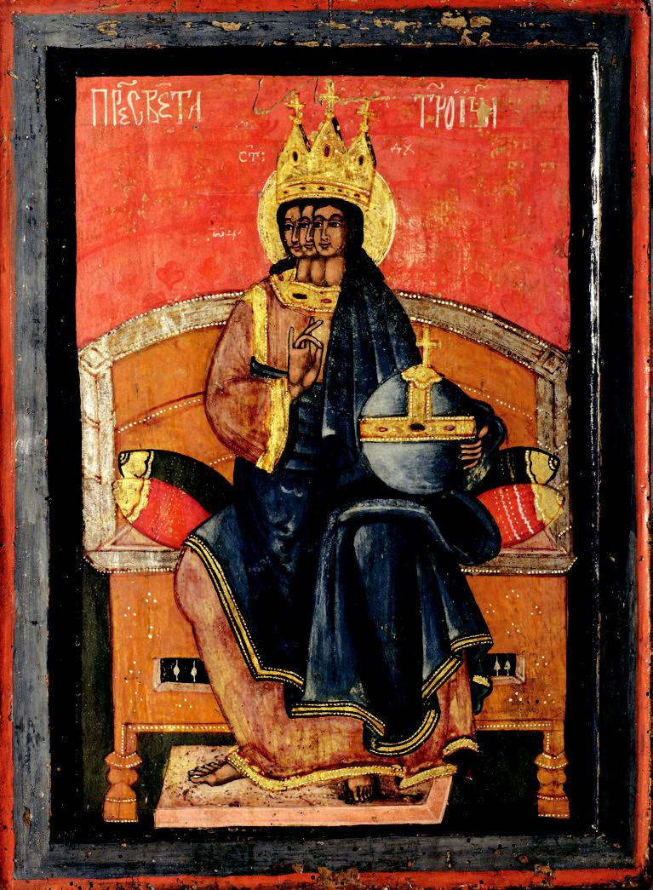

Fig. 3. Holy Trinity, icon, 48.5 x 35.5 cm, Kozma Damjanović (attributed), 1704 (photo: courtesy of the Museum of Serbian Orthodox Church, Belgrade) Фиг. 3. Света Троица, икона, 48,5 x 3515 см, Козма Дамянович (по атрибуция), 1704 г. (фотография: с любезното разрешение на Музея на Сръбската православна църква, Белград)

has records of many iconographic variations of three-headed images of the Holy Trinity4, these were, as Grujić rightfully ascertained, quite unique in several aspects. The aim of this paper is to shed some fresh light on the unique occurrence of these icons in a specific geographical and historical context. All direct evidence comes from the inscriptions preserved on the icons themselves, and on the three royal doors (Fig. 3–4) executed by the same painter for the same three churches5. Admit-tedly, the bulk of indirect sources stems from Grujić’s published but, unfortunately, often insufficiently corroborated remarks, and unpub-lished personal notes6.

Grujić provided the first transcriptions of the dedicatory inscriptions on the icons and royal doors made by painter Kozma Damjanović,

4 For more recent comprehensive overviews see Vojvodić 2011: 79–88; Kuyumdzhieva 2018: 143– 174.

5 Two of the latter are preserved and also housed in the Museum of Serbian Orthodox Church in Belgrade.

6 After Grujić’s initial investigation of the Orthodox heritage in Northern Croatia came the First and the Second World Wars, but also the Yugoslav wars in the 1990s and the consequential waves of destruction of churches and artifact, or their dislocation from original contexts without documentation or any proper investigation. In these circumstances, the findings of Grujić, who observed and made first hand notes about the artifacts still largely in situ, acquired widespread recognition and credibility in Serbian scholarship. His large personal archive, still harboring important unpublished works, can be accessed in the Museum of Orthodox Church in Belgrade.

Marginalia

239

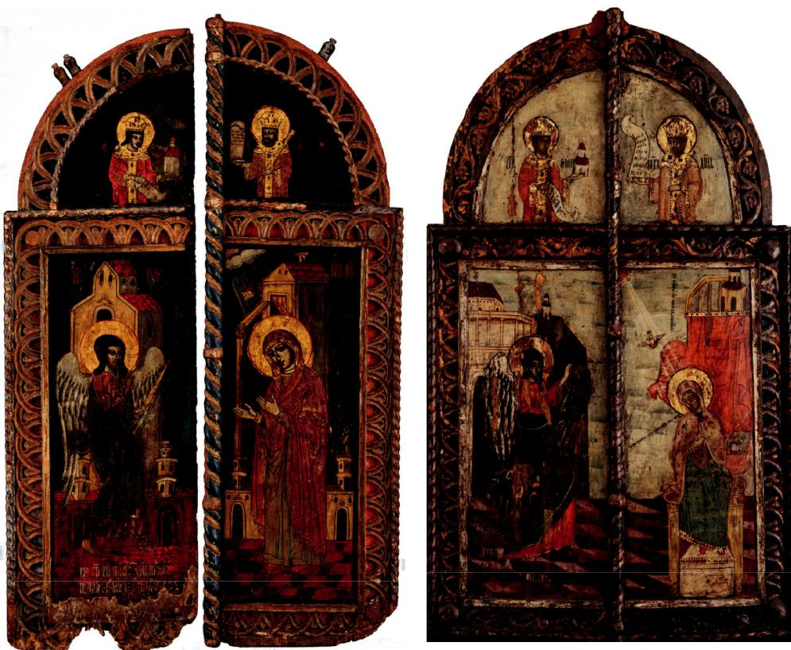

Fig. 4. Royal doors, Kozma Damjanović, 1704 (photo: courtesy of the Museum of Serbian Orthodox Church, Belgrade)
Фиг. 4. Царски двери, Козма Дамянович, 1704 г. (фотография: с любезното разрешение на Музея на Сръбската православна църква, Белград)

Fig. 5. Royal doors, Kozma Damjanović, 1705 (photo: courtesy of the Museum of Serbian Orthodox Church, Belgrade)
Фиг. 5. Царски двери, Козма Дамянович, 1705 г. (фотография: с любезното разрешение на Музея на Сръбската православна църква, Белград)

and, as such, they were first published in 19257. The two icons de-picting the Holy Trinity on the throne in imperial robe bear the sig-nature of the painter in full name, with the year 1704 inscribed on the one from Široko Selo8. The inscriptions state the private nature of the icons’ commission – the painter himself was their donor to the afore-mentioned churches, painting them for the sake of his own health and the salvation of his soul. The third icon, with the Trinity dressed in Christ’s robe, bears no dedicatory inscription9. More information

7 Stojanović 1987: 6–9, nos. 7313, 7314, 7322, 7332, 7333. Under each transcription the author cites Grujić as the original transcriber and provider of the inscriptions.

8 Cited here after Stojanović 1987: 7, 9, nos. 7322 and 7333. Cf. Todić 2013/1: 296.

Сїю икон с(ве)тие троице приложи с(вето)м про(ро)к Илїи Козма Дам новићь нареч(е)ни писаць, себе и
своем ... ѡн ... на здравие, д( )ши на спасение а҃ ѱ҃ д҃

Сїю икон писа недостои ною р кою Козма Дам новићь и положи за свою д( )ш .

9 The influence of Grujić’s claims can probably best be ascertained in the case of this icon with

240

is provided by the inscriptions on the royal doors painted by Kozma
– they were executed “through effort and endeavor” of the presbyter Marko Milaković during the time of the Bishop of Vretanija Gavrilo Turčinović10.

It is well known that official Christian theology, Eastern or Western, has never accepted the controversial depictions of the Trinity as one body with three heads or faces. The images, when referred to by the-ologians or ecclesiastical regulations, have been almost unanimously disapproved of as monstrous and erroneous11. The very fact that they were rejected meant that they were not regulated by the Church in any way. That opened up the path to many popular variants and a wide range of interpretations during the Middle Ages and later, both East and West. As Radoslav Grujić observed in the aforemen-tioned study, the three-headed or three-faced Trinity images fall roughly into two main groups determined by the way in which the three guises are depicted and understood in iconographical terms. The popular Western depictions of Vultus trifrons, showing Trinity as three-headed or three-faced Christ with long hear and beard have more pronounced Christological inclinations and fall into the sim-ilar interpretative scope with other accepted anthropomorphic de-pictions of the so-called New Testament Trinity12. The influence of such a model, essentially Western in origin, was also felt in the East,

no dedicatory inscriptions and somewhat different in style than the other two signed by Kozma Damjanović. Grujić’s attribution was later universally accepted. Mileusnić 1997: 148–149; Mileus-nić 2003: 27; Stošić 2003: 176; Stošić 2006: 147; Todić 2013/1: 296–297.

10 Dedicatory inscriptions on the two preserved royal doors from the villages Gornje Sredice and Povelič, after Stojanović 1987: 6, 9, nos. 7314 and 7332:

Сїе с(ве)тїе двери саписаше се троудомь и подвигомь презвитера кирь Марка. Лет(о) г(оспод)н(е) а҃ ѱ҃ д҃ К(озма) Д(ам новићь).

Саписаше се сїе с(ве)тїе двери троудомь и подвигомь презвитера кирь попа Марка Милаковића а҃ ѱ҃ е҃ К(озма) Д(ам новићь).

The initials К Д are interpreted as belonging to Kozma Damjanović also exclusively by Gru-jić. The Royal doors from the village of Široko Selo, which bore the dedicatory inscription with more important information about the commissioner, the bishop and other protagonists are not preserved and the only surviving testimony is the published inscription transcribed by Grujić. Cited here after Stojanović 1987: 6, no. 7313:

Саписаше се сїе с(ве)тїе двери троудомь и подвигомь презвитера кѵр’ попа Марка Мїлаковића, при г(о)с(по) (ди)н Вретанїском’ владице кѵр’ Гаврил Т рчиновїћ . К( змань) Д(ам новићь). Оуби Петрь Виленић’ Иларїѡна Чавїћа. По томь тога наће ѡпщина црковна двери сїе ... да му ѡ к пи за негов д( )ш . И ѡ к пи више реченога старїи брат В комань. Лета г(оспо)дн а҃ ѱ҃ д҃
11 Grujić 1955: 107; Deswarte-Rosa 2013: 236–242; Hallebeek 2007: 353–384; Uspenskii 2009: 196–207.
12 Grujić 1955: 99–100, 106–107. For the contemporary scholarly understanding of the visual
concepts of the Old and New Testament Trinity see Kuyumdzhieva 2007: 162, 168.

Marginalia

241

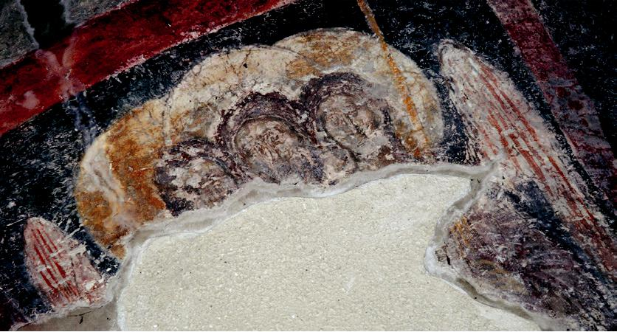
Fig. 6. The three headed angel, Ramaća Monastery, end of the 14th century (photo: Miodrag Marković) Фиг. 6. Триглав ангел, манастир Рамача, край на ХІV в. (фотография: Миодраг Маркович)
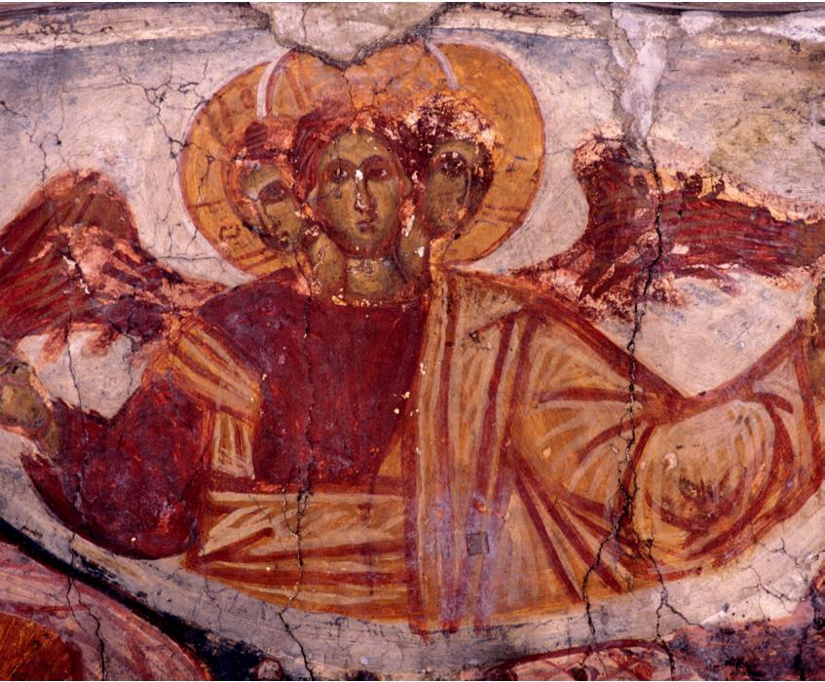

Fig. 7. The three headed angel, Temska Monastery, 1576 (photo: courtesy of Institute for the Protection of Cultural Monuments of Serbia, Belgrade)

Фиг. 7. Триглав ангел, манастир Темска, 1576 г. (фотография:
с любезното разрешение на Републикански институт за защита на паметниците на културата, Белград)

especially in the post-Byzantine Balkan region. The examples known from the oeuvre of the painter Onufri in the 16th century have been linked to South-Italian pictorial and devotional practices connected to the Holy Trinity13. Onufri is denoted as the introducer of this type to the Balkan region, followed and developed by successive painters until the 19th century14.

The other group identified by Grujić encompasses all the variants when the triune God is shown as one body with three youthful or an-gelic heads, which he associated with the depictions of the Old Testa-ment Trinity, recognized by the Church and based upon the episode of the Hospitality of Abraham15. The angelic three-headed Trinities have been present in Christian art since the 13th century16. The Dream

13 Roçi, Arapi 2016: 156–158.

14 Roçi, Arapi 2016: 155. Other fantastic visual combinations of Eastern provenance can be interpreted along those lines – when the three-headed entity, in one such example, features three different heads – God the Father, Christ Emmanuel and the third head as the dove of the Holy Ghost. Paissidou 2001: 373–392.

15 Grujić 1955: 102; cf. Vojvodić 2011: 84–85.

16 Kuyumdzhieva 2007: 148–149.

242

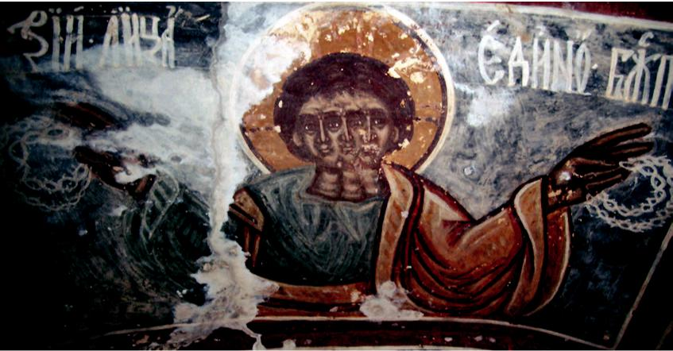
Fig. 8. “Three faces, one deity”, Church of Saint Kliment, Mostaći, ca. 1623 (photo: Nina Lojović Milinić)
Фиг. 8. „Три лица, едно божество“, църква „Св. Климент“, Мостачи, ок. 1623 г. (фотография: Нина Лойович Милинич)

of Nebuchadrezzar in the narthex of the Virgin Peribleptos Church in Ohrid (1294–1295), featuring the female personification with wings and three equal heads, has been pointed out as the pivotal moment for the development of such images in late and post-Byzantine domains17. The three-headed winged figure appearing in the fresco Wisdom Has Built Her House in the narthex of Chilandariou Monastery (ca. 1320) is yet another example of the adaptability and multifunctionality of this type of representation18. The extrication and more pronounced hierat-ic setting of the tricephalous images in Eastern pictorial tradition can be traced back to the famous example from Matejče Monastery (after 1355)19. The post-Byzantine Balkan region subsequently produced a variety of related solutions with different iconographical accents – as witnessed by the examples from the churches of Sveti Spas in Štip (ca. 1380)20, Saint Nicholas in Ramaća (end of the 14th century)21 (Fig. 6), skete in Belaja near Dečani Monastery (mid-15th century)22, Zrze (1535)23 and Temska (1576)24 (Fig. 7) monasteries and from the Church of Saint Kliment in Mostaći near Trebinje (ca. 1623)25 (Fig. 8). The influence of the Matejče visual model in particular can be traced as far as early 19th century, taken up by the painter Aleksije Lazović from Bijelo Polje26.

17 Grozdanov 2012: 109–122. The image represents a visual amalgam of the ideas of the Trinity, with absolute equality of hypostases suggested by one halo and the identity of the heads, and the Wisdom of God. However, it has been suggested that this type of a figure could not jet be understood as a three-headed angel. Vojvodić 2011: 81–82.

18 The fresco has been repainted in 1804, but it is believed that the repainting retained its original iconographical features. Marković 1998: 239; Vojvodić 2011: 83.

19 The fresco is now very damaged, but it is believed that it used to bear an inscription designating it as the image of the Holy Trinity. Grujić 1955: 100–101; Dimitrova 2002: 196–197; Vojvodić 2011: 83.

20 Gabelić 2009: 102–103.

21 Starodubcev 2016: 223; Vojvodić 2011: 84.

22 Vojvodić 2011: 79–88.

23 Babić 1980: 272–275; Vojvodić 2011: 84, 86.

24 Cunjak 2013: 48.

25 Grujić 1955: 102; Petković 1965: 73–74.

26 The two diptichons dating from 1812–1817 and 1818 and representing the Virgin with Christ and three-headed Holy Trinity on their respective sides are housed in Dečani and Studenica

Marginalia

243

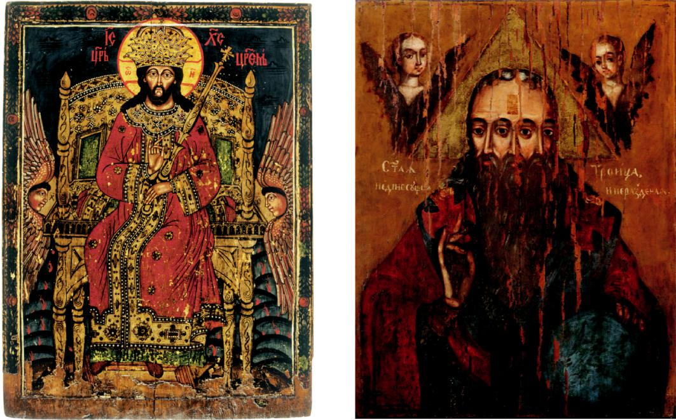

Fig. 9. Christ as King of Kings, first half of the 18th century (photo: courtesy of Gallery of Matica Srpska, Novi Sad)
Фиг. 9. Христос Цар на царете, първа половина на ХVІІІ в. (фотография: с любезното разрешение на Галерия на Матица сръбска, Нови Сад)

Fig. 10. Holy Trinity, first half of the 18th century (photo: courtesy of Gallery of Matica Srpska, Novi Sad)
Фиг. 10. Света Троица, първа половина на ХVІІІ в. (фотография: с любезното разрешение Галерия на Матица сръбска, Нови Сад)

In the northern and western bordering regions of Balkan Orthodoxy in the 17th and early 18th centuries such images were taken up by the popular visual culture, with many under-skilled painters as its protagonists27. One of them was Kozma Damjanović, who appeared in Northern Croatia in the first decade of the 18th century. The inscriptions on his works cited above do not provide any hints about his origin. After the Austro- Turkish wars at the end of the 17th century the region of Slavonia and Northern Croatia received a strong migratory wave from different parts of the Balkans. Some other painters known by name, who were active in the Orthodox communities approximately at the same time, such as Sava Krabulević and Ostoja Mrkojević, were almost certainly not native to the region28. Radoslav Grujić claimed that Damjanović

monastery treasuries. They seem to represent, contrary to Grujić’s belief, the latest known exam-ples in Serbian religious painting. Šakota 1984: 125, 166; Šakota 2015: 89, 243–244.

27 Timotijević 1996: 131–151; cf. Stošić 2006: 139–143.

28 Todić 2013/2: 73–75, 119–120.

244

was from the Croatian town of Kostajnica, but unfortunately never substantiated this statement with enough evidence29.

However, what can be said with certainty is that painting activity of Damjanović occurred on the historical backdrop of almost a century long battle for ecclesiastical jurisdiction over the Orthodox population in Northern Croatia. The Greek-Catholic bishopric of Marča was officially established in 1611 by the Pope Paul V who confirmed the jurisdiction of Bishop Simeon Vretanja in Hungary, Croatia, Slavonia and Žumberak30. Serbian historiography has claimed that the bishopric was actually originally Orthodox because Bishop Simeon was appointed also by the Patriarch of Peć Jovan in 1609, and that the subsequent bishops of Marča were installed in Peć as Orthodox bishops during the 17th century31. The clash between Croatian and Serbian church historians on the subject of the confessional loyalty of the bishops of Marča is still unresolved, and different interpretations of historical sources only highlight the complicated and often violent history of this diocese32. By confirming the jurisdiction of Bishop Simeon, the Pope expected the gradual implementation of the Church Union among the Orthodox in the Habsburg Military Frontier. Marča Monastery became the center of this activity, renewed by the Bishop Simeon and located on the estates of the Catholic bishop of Zagreb33. Serbian historiography interpreted the unstable position of the bishops of Marča as accepting the Church Union only on a formal level, in view of the fact that they could “always be the officials of the bishop of Zagreb” having the “power both from the Patriarch and from the Pope”34. The lower clergy, however, together with the bulk of the Orthodox population, remained loyal to their old faith.

29 Grujić 1955: 103. In the latest research, Grujić’s claim was taken with caution. Todić 2013/1: 296–297. If true, however, it might imply the Bosnian origins of the painter. Unfortunately, there is no solid evidence for now to take this conviction any further. His name appears for the last time in 1728 when he witnessed the drawing up of the testament of the Bishop of Kostajnica Nikanor Dimitrijević. Hovewer, the document does not state the occupation of Kozma Damjanović who signed it as the first witness, so it can not be said with certainty that this was the same person. Ru-varac 1905: 290. The Orthodox community in Kostajnica had connections to the south Balkans and Bosnia at the beginning of the 18th century, proven by liturgical artifacts from Zrze and Rmanj monasteries, kept in its churches. Šerović 1933: 364–365.

30 Kudelić 2007: 159–191; Kudelić 2010: 136–138.

31 Kašić 1986: 17–44; Grujić 1996: 56–60.

32 Smiljanić 2008: 462–477.
33 Grujić 1996: 59–60; Kudelić 2010: 138. The monastery fell into ruins after 1755 when the Ortho-
dox monks were finally driven out of it. Kašić 1996: 316–342.

34 Grujić 1996: 62.

Marginalia

245

When Patriarch of Peć Arsenije III visited Marča Monastery in 1692– 1693, the circumstances for Marča bishops changed dramatically. The Patriarch was then embarking on an ambitious campaign to crush the Church Union in the region and achieve the confirmation of his jurisdiction over the entire Orthodox population in Hungary, Croatia and Slavonia35. The Catholic Church, unwilling to give up the rights of Greek-Catholic bishops of Marča, prepared a counter-offensive masterminded by the Catholic Primate of Hungary, Cardinal Leopold Karl von Kollonitsch36. Serbian historiography ascribed the failure of the latter to the fact that in 1703 the uprising of Francis II Rákóczi began and that Vienna court needed the loyalty of its Orthodox subjects on Hungarian soil, thus temporarily deactivating attempts for their conversion in Northern Croatia37.

The upheavals of Rákóczi rebellion and churnings among the popu-lation of different denominations in Northern Croatia mark the pe-riod of Marča Bishop Gabriel Turčinović (1701–1707), who was men-tioned by painter Kozma Damjanović on the royal doors painted for the church in Široko Selo, situated north-east of Marča Monastery. Serbian sources characterized Turčinović as being “a quiet man, who did not flaunt with the Union” and who was accepted by the major-ity of Orthodox believers, as were the priests ordained by him38. The Chronicle of Marča and Lepavina monasteries, begun after 1745, re-members Turčinović as an honorable and peaceful bishop, unlike oth-ers before and after him promoting the Union forcefully and deemed by the chronicler as “blood thirsty wolves… who crushed the Lord’s gate of the Holy Sion and devoured the spiritual flock of Christ”39. We can assume that priest Marko Milaković, who paid Damjanović to paint three royal doors for iconostases in churches of his large par-ish, was a trustee of Bishop Turčinović in those difficult times.

The precariousness of the position and shifting loyalties of Marča bishops could be seen as reflected in the unique iconographical scheme of the three icons of Holy Trinity painted by Kozma Damjanović.

35 Serbian church historian Dušan Kašić called this period of Patriarch’s northern visitations “a strange one, when bishops of Marča were propter obedientiam Greek-Catholic, but propter populum Orthodox…” Kašić 1986: 28; cf. Grujić 1996: 85.

36 Kašić 1986: 19–26; Kudelić 2007: 379–393.

37 Kašić 1986: 28–29; Kudelić 2007: 406–407.

38 Kašić 1986: 27; cf. Kudelić 2007: 394–411; Kudelić 2010: 156–157.

39 Letopis 2013: 75, 77.

246

Admittedly, significant differences could be observed between them. Two of them feature seated figures in imperial sakkoi, with royal scepters and triple crowns on their heads, while the third is dressed as Christ, holds the Mundus on his knee and differently fashioned, but still with a triple crown40. Previous research rightfully pointed towards the iconographical variant of Christ as King of Kings as the basic template for Damjanović’s rendering of the theme, especially in the cases of the first two icons41. The images of Christ as King of Kings were particularly favored by painters working in Orthodox communities on the northern and western fringes of Balkan Orthodox world in late 17th and early 18th century42 (Fig. 9). Their particularity is accentuated by the specific form of Christ’s crown consisting of three coronets placed one above the other. This represented a reference to papal tiara and it was used to visually refute the idea of primatus papae, by showing it on the head of Christ as the only rightful head of the Heavenly and Earthly Churches43. By stressing the Christ’s kingship and appropriating the tiara crown form, the image became distinctly polemical in nature and would have served as sort of a visual argument against the Church Union, which primarily requested the acceptance of the absolute rule of the Roman pope. The bishops of Marča, as already pointed out, obeyed that law, nominally or truthfully, throughout the period. By placing such a crown on the figures of three-headed images of the Holy Trinity painter Kozma Damjanović made an even more convincing visual argument in favour of the Orthodox ecclesiology and understanding of the nature of power and hierarchy in the Church. He also devised an ingenious way of merging it with yet another point of dispute between Catholic and Orthodox Churches, the filioque dogma, marking the Orthodox stance by painting the three heads as absolutely equal and with no hints of hierarchy between them44. Damjanović adheres here to the solutions devised by painters ever since Virgin Peribleptos of Ohrid example, where the three heads are shown in semi-profile – a painterly solution to the problems posed by showing the three heads enface45.

40 All three images are designated as the Holy Trinity by inscriptions and have additional abbreviations added for Father, Son and the Holy Spirit.

41 Stošić 2003: 176–178.

42 Stošić 2003: 172–175.

43 Stošić 2003: 173; Stošić 2006: 148–150.

44 Stošić 2006: 147.

45 Vojvodić 2011: 87.

Marginalia

247

It is important to note that, although particular as iconographical compilations, the three icons of Kozma Damjanović are not unique in terms of usage of three-headed Trinity images as polemic tools in contacts of the Orthodox and Greek-Catholics. The Trinity images of the Vultus trifrons type appear, for example, in the mid-18th century Transylvania in churches of Galda de Jos and Custelnic where disputes between Orthodox and Greek Catholics arose at the same time. The introduction of such images to the Transylvanian soil was explained partly as a result of confessional clashes and the need to visualize the complicated Trinitarian dogma to the illiterate folk in a manner as explicit as possible, but it was also pointed out that the initiative of painters themselves in using this unofficial image should not be excluded46. The same could also be said for the north Croatian icons because the inscriptions on two of them state that they were personal votive gifts of painter Kozma. Their small size suggests that they were probably not permanently displayed in the corresponding churches, but only on particular festal and ritual occasions. It is also worth noting that one Vultus trifrons is preserved as a fresco, dating from the late 16th century, in the Catholic Church of Saint Brcko in Kalnik, not far away from Orthodox village communities for which Kozma painted his icons47. All the other known examples of three-headed Holy Trinity images from the territory of the Orthodox Metropolitanate of Karlovci, dating from the 18th century, also belong to this type, showing half-length bearded figures with three faces48 (Fig. 10).

The three strange icons from North Croatian villages around Marča Monastery could have been the result of an understanding and friendship of the shrewd and politically conscious priest Marko Milaković, who navigated the unstable ecclesiastical and jurisdictional situation, explaining it to his parishioners, and a rather unskilled, but by no means unlettered painter. The appearance of the three-headed Trinity images on the icons painted by Kozma Damjanović, with no exact iconographic precursors known so far, serves as a good illustration of the versatility and impromptu adaptive qualities of the post-Byzantine pictorial models when put in an immediate dialogue with the Catholic world.

46 Dumitran 2010: 238–249; Sabău 2017: 5–47.

47 Kašić 1987: 105; Cvetnić 2007: 57–59, fig. 10.
48 Grujić 1955: 103–105, fig. 1. The other two examples are kept in the Gallery of Matica Srpska
in Novi Sad and have not been previously publihed. Cf. Šelmić 2001: 217.

248

Bibliography

Babić 1980: Babić, Boško. Фреско-живопис сликара Онуфрија на зидовима цркава прилепског краја [Fresko-živopis slikara Onufrija na zidovima crkava pri-lepskog kraja]. – Зборник Матице српске за ликовне уметности [Zbornik Matice srpske za likovne umetnosti], No. 16, 271–280.

Cunjak 2013: Cunjak, Mlađan. Манастир Светог Ђорђа – Темска [Manastir Svetog Đorđa – Temska]. Temska.

Cvetnić 2007: Cvetnić, Sanja. Ikonografija nakon Tridentskog sabora i hrvatska liko-vna baština. Zagreb.

Deswarte-Rosa 2013: Deswarte-Rosa, Sylvie. La Trinité trifrons en France dans le sil-
lage de Savonarole. In: Circulation des idées et des pratiques politiques, France et Italie (XIIIe – XVIe siècle) (eds. Anne Lemonde, Ilaria Taddei). Rome, 235–248.

Dimitrova 2002: Dimitrova, Elizabeta. Манастир Матејче [Manastir Matejče].
Skopje.

Dumitran 2010: Dumitran, Ana. Representations of the Three Faced Holy Trinity in the Romanian Environment from Transylvania. Theological Significations, Ways of Spreading, Diverse Ways of Artistic Expression. In: Actes du XIVème Congrès inter-national d’études sur les danses macabres et l’art macabre en général (eds. Cristina Bogdan, Silvia Marin-Barutcieff). Bucureşti, 238–249.

Gabelić 2009: Gabelić, Smiljka. Сликарство XIV века у Св. Спасу (цркви Вазнесења)
- Штипу [Slikarstvo 14. veka u Sv. Spasu (crkvi Vaznesenja) u Štipu]. – Patrimo-nium.mk, No. 3–6, 97–116.

Grozdanov 2012: Grozdanov, Cvetan. О живопису на северном зиду нартекса Богородице Перивлепте (Светог Климента) у Охриду [O živopisu na severnom zidu narteksa Bogorodice Perivlepte (Svetog Klimenta) u Ohridu]. – Zograf, No. 36, 109–114.

Grujić 1955: Grujić, Radoslav M. Ikonografski motiv sličan induskom Trimurtiu u sta-
roj srpskoj likovnoj umetnosti. In: Tkalčićev zbornik. 1. Zagreb, 99–109.

Grujić 1996: Grujić, Radoslav M. Споменица о српском православном владичанству пакрачком [Spomenica o srpskom pravoslavnom vladičanstvu pa-kračkom]. Belgrade.

Grujić 2016: Grujić, Radoslav M. Србуље у бившем Вараждинском генералату и Славонији [Srbulje u bivšem Varaždinskom generalatu i Slavoniji]. Zagreb.

Hallebeek 2007: Hallebeek, Jan. Papal Prohibition Midway Between Rigor and Laxity. On the Issue of Depicting the Holy Trinity. In: Iconoclasm and Iconoclast. Strug-gle for Religious Identity (eds. Willem Van Asselt, Paul Van Geest et al.). Leiden, 353–348.

Kašić 1986: Kašić, Dušan. Отпор марчанској унији: Лепавинско-северинска
епархија [Otpor marčanskoj uniji: Lepavinsko-severinska eparhija]. Belgrade.

Kašić 1996: Kašić, Dušan. Српски манастири у Хрватској и Славонији [Srpski manastiri u Hrvatskoj i Slavoniji]. Belgrade.

Marginalia

249

Kudelić 2007: Kudelić, Zlatko. Marčanska biskupija: Habsburgovci, pravoslavlje i crk-vena unija u Hrvatsko-slavonskoj vojnoj krajini (1611–1755). Zagreb.

Kudelić 2010: Kudelić, Zlatko. Čaplovićeva povijest Marčanske biskupije. – Povijesni prilozi, No. 38, 135–182.

Kuyumdzhieva 2007: Kuyumdzhieva, Margarita. The Face of God’s Divinity. Some Remarks on the Origin, Models and Content of the Trinity Images of Synthronoi Type in Post-Byzantine Painting. – Scripta & e-Scripta, No. 5, 161–182.

Kuyumdzhieva 2018: Kuyumdzhieva, Margarita. Ликът на Бога. Изображенията на Света Троица в православното изкуство [Likat na Boga. Izobrazhenijata na Sveta Troica v pravoslavnoto izskustvo]. Sofia.

Letopis 2013: Летопис манастира Марче и Лепавине. Изворни текст и превод. Приредио и на савремени језик превео Томислав Jовановић) [Letopis manasti-ra Marče i Lepavine. Izvorni tekst i prevod (ed. and trans. Tomislav Jovanović)]. Belgrade.

Marković 1998: Marković, Miodrag. Првобитни живопис главне манастирске
цркве [Prvobitni živopis glavne manastirske crkve]. In: Манастир Хиландар (прир. Гоjко Суботић) [Manastir Hilandar (ed. Gojko Subotić)]. Belgrade, 221– 242.

Marković 2014: Marković, Ignatije. Прота др Радослав Грујић у свом и нашем времену – поводом рехабилитације [Prota dr Radoslav Grujić u svom i našem vre-menu – povodom rehabilitacije]. – Bogoslovlje, No. 1, 161–173.

Mileusnić 1997: Mileusnić, Slobodan. Српско црквено сликарство у Славонији
- време патријарха Арсенија III Чарнојевића [Srpsko crkveno slikarstvo u Slavoniji u vreme patrijarha Arsenija ІІІ Čarnojevića]. In: Патријарх Арсеније

III Чарнојевић и Велика сеоба Срба 1690. године: Зборник радова о тристагодишњици Велике сеобе [Patrijarh Arsenije III Čarnojević i Velika seoba Srba 1690 godine: Zbornik radova o tristagodišnjici Velike seobe] (ed. Sava, Bishop of Šumadija)]. Belgrade, 143–150.

Mileusnić 2003: Mileusnić, Slobodan. Византина у црквеном сликарству Славоније [Vizantina u crkvenom slikarstvu Slavonije]. – Зборник Матице српске за ликовне уметности [Zbornik Matice srpske za likovne umetnosti], No. 34–35, 19–29.

Paissidou 2001: Paissidou, Melina. Η ανθρωπόμορφη Αγία Τριάδα στον Αγίο Γεώργιο της Ομορφοκκλησιάς Καστοριάς. In: Αφιέρωμα στη μνήμη τον Σωτήρη Κίσσα. Thessaloniki.

Petković 1965: Petković, Sreten. Зидно сликарство на подручју Пећке патријаршије 1557–1614 [Zidno slikarstvo na području Pećke patrijaršije 1557–1614]. Belgrade.

Roçi, Arapi 2016: Roçi, Holta, Dorina Arapi. Onofrio e l’atelier di Berat. Influssi dell’arte del Rinascimento fiorentino nell tema iconografico della Trinita’ tricefala. In: Byzantium and the Heritage of Europe: Connecting the Cultures. Proceedin-gs of the 3rd International Symposium “Days of Justinian I” (ed. Mitko B. Panov). Skopje, 152–160.

Ruvarac 1905: Ruvarac, Dimitrije. Тестаменти владичански [Testamenti vladičans-ki]. – Srpski Sion, No. 15, 289–295.

250

Sabău 2017: Sabău, Nicolae. Între Occident si Orient. “Sfânta Troiţă într-un singur trup” si “Vultus Trifrons”, in câteva exemple ale picturii religioase transilvănene. – Studia UBB Historia Artium 62, No. 1, 5–47.

Smiljanić 2008: Smiljanić, Irena. Zlatko Kudelić. Marčanska biskupija. Habsburgovci, pravoslavlje i crkvena unija u Hrvatsko-slavonskoj Vojnoj krajini (1611–1755). – Ljeto-pis Srpskog kulturnog društva “Prosvjeta”, No. 13, 462–477.

Starodubcev 2016. Starodubcev, Tatjana. Српско зидно сликарство у земљама Лазаревића и Бранковића [Srpsko zidno slikarstvo u zemljama Lazarevića i Brankovića]. Vols. 1, 2. Belgrade.

Stojanović 1987: Stojanović, Ljubomir. Стари српски записи и натписи [Stari srpski zapisi i natpisi]. Vol. 5. Belgrade.

Stošić 2003: Stošić, Ljiljana. The Representation of Christ as King of Kings with a Triple Crown. – Зборник Матице српске за ликовне уметности [Zbornik Matice srpske za likovne umetnosti], No. 34–35, 167–180.

Stošić 2006: Stošić, Ljiljana. Српска уметност 1690–1740 [Srpska umetnost 1690– 1740]. Belgrade.

Šakota 1984: Šakota, Mirjana. Дечанска ризница [Dečanska riznica]. Belgrade.

Šakota 2015: Šakota, Mirjana. Студеничка ризница [Studenička riznica]. Novi Sad.

Šelmić 2001: Šelmić, Leposava et al. Галерија Матице српске [Galerija Matice srpske]. Novi Sad.

Šerović 1933: Šerović, Petar D. Натписи на разним старинама у костајничким црквама [Natpisi na raznim starinama u kostajničkim crkvama]. – Glasnik Istori-jskog društva u Novom Sadu, No. 6/3, 356–366.

Timotijević 1996: Timotijević, Miroslav. Srpsko barokno slikarstvo. Novi Sad.

Todić 2013/1–2: Todić, Branislav. Српски сликари од XIV до XVIII века [Srpski slikari od 14 do 18 veka]. Novi Sad.

Uspenskii 2009: Uspenskii, Leonid. Теологија иконе [Teologija ikone]. Chilandar Monastery.

Vojvodić 2011: Vojvodić, Dragan. Скит Успења Богородичиног у Белаји [Skit Uspenja Bogorodičinog u Belaji]. In: Дечанска пустиња. Скитови и келије манастира Дечана [Dečanska pustinja. Skitovi i kelije manastira Dečana]. Belgra-de, 57–131.

Marginalia

251

Хърватските икони на св. Троица с три глави – в периферията на поствизантийската народна вяра

Александра Кучекович


- самото начало на ХVIII в. зографът Козма Дамянович изписва три необичайни икони на св. Троица и ги дарява на църквите в три села в Северна Хърватия. И трите се съхраняват в Музея на Сръбската православна църква в Белград и представят особе-но, неканонично изображение на св. Троица – фигура на трон в императорска или Христова мантия с три еднакви глави на три шии, увенчани с обща тройна корона. Макар в православната иконопис на Балканите да са документирани няколко иконог-рафски варианта на св. Троица с три глави през византийския и поствизантийския период, хърватските икони са уникални в няколко съществени аспекта.

Статията има за цел да наблегне върху иконографските особе-ности на трите разглеждани икони и да ги впише в контекста на общата картина на явленията в поствизантийската визуална култура на Балканите. Тяхната идентичност на маргинални изо-бражения от маргинални православни територии представлява важен аспект на контекстуалния анализ. Като се има предвид, че е създавана за най-необразованите православни общности, подложени на непрекъснат натиск да приемат католицизма, иконографията на трите икони се отличава със специфични ха-рактеристики. Тази иконография представя по достъпен начин на обикновените хора, за които е предназначена, съществени богословски въпроси: от живо илюстративно „обяснение“ на сложния догмат за Светата Троица до становището по най-същ-ностния за Православната църква проблем – неприемане върхо-венството на папата. От друга страна, макар и да са били полез-ни в така очертания контекст, каноничната неприемливост на този тип изображения на св. Троица, уникалният им облик и обстоятелството, че други такива икони повече не се появяват, ги превръща в автентични визуални marginalia от късния поствизан-тийски свят.

252

